How We “Count” New Believers

-- When we say that 900 people a day tell us they’ve asked Jesus into their life while on the site…do you ever wonder if these stats are real? Let me show you how we report new believers.

-- On some evangelistic sites you’ll see something bold like this on every page.

-- Not on EveryStudent.com.

In fact, 80% of the pages on our site contain no gospel presentation, and no prayer to receive Christ.

On the articles that include the gospel, they are typically long articles.

-- “Is There a God?” is a typical example. Let me show you want a person reads, before they could indicate they received Christ.

Here’s what a person reads:

[Scroll “Is There a God?”]

At the end of this 2,400-word article are these three links:

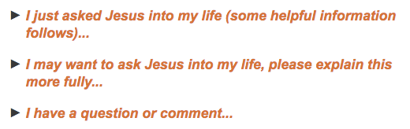

When someone clicks the first link, that’s what we “count” as indicating they asked Jesus into their lives.

The second link takes them to the Four Spiritual Laws (Knowing God Personally) page.
The third link lets them send a question or comment by email.

We don’t know if people who click the first link really asked Jesus into their lives. And we don’t know how many did ask Jesus into their lives, but didn’t click the link.

We do know, that on the English site, 35% of them give their email address and sign up for The Spiritual Starter Kit. Another 10% go directly to the growth site for new believers, StartingwithGod.com. So, 45% of those continue into followup, which is a pretty high percent.

